Lab 03 – Worksheet

Name: Faaz Shahab, Mohib Ul Mehdi, Basim Hussain | ID: fs09911, mm09730, mh09732 | Section: T2

Note: Assumptions and logics should be explained separately in tasks after the task results.

Task 1

Provide appropriately commented codes (Mention question part before each part)
addi x10,x0,12
addi x11,x0,12
jal x1,sum #calls the function named sum
addi x11,x10,0
li x10,1
ecall
j exit
sum:
add x10,x11,x10
jalr x0,0(x1)
exit:
j exit

Add screenshot of your results (register) & Terminal Console
Ecall result/ Terminal Output:

Register results:
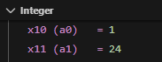

Task 2

Provide appropriately commented codes (Mention question part before each part)

li x10, 1 # g = 1
li x11, 2 # h = 2
li x12, 3 # i = 3
li x13, 4 # j = 4
li x2, 0x100

jal x1, arithmetic
addi x11, x20, 0
li x10, 1
ecall
j end

arithmetic:
addi x2, x2, -12
add x18, x10, x11 # x18 = g + h
add x19, x12, x13 # x19 = i + j
sw x18, 0(x2) # store (g + h) to stack
sw x19, 4(x2) # store (i + j) to stack
sub x20, x18, x19 # x20 = (g + h) - (i + j)
sw x20, 8(x2) # store result to stack
lw x18, 0(x2) # load (g + h) from stack
lw x19, 4(x2) # load (i + j) from stack
lw x20, 8(x2) # load result from stack
addi x2, x2, 12
jalr x0, 0(x1)

end:
j end

Add screenshot of your results (registers & memory)

Register: Ecall result/ Terminal Output:
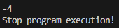
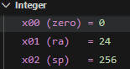 Memory:
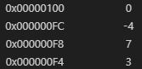
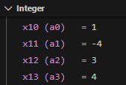
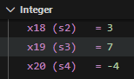

Task 3 Provide appropriately commented codes
li x10, 0x100 # v[] = 0x100
li x11, 4 # k = 4
li x5, 42 # swap1 = 42
li x6, 84 # swap2 = 84
li x2, 0x200 # stack pointer
jal x1, swap
li x10, 10
ecall
j end

swap:
addi x2, x2, -16
sw x18, 0(x2)
sw x19, 4(x2)
slli x18, x11, 2 # x18 = k * 4 (word size)
add x18, x10, x18 # x18 = address of v[k] 116
sw x5, 0(x18) # v[k] = swap1 42
lw x20, 0(x18) # temp = v[k] 42
sw x20, 8(x2) # store temp to stack 42
addi x19, x18, 4 # x19 = address of v[k+1] 120
sw x6, 0(x19) # v[k+1] = swap2 84
lw x21, 0(x19) # temp2 = v[k+1] 84
sw x21, 12(x2) # store temp2 to stack 84
lw x7, 12(x2) # load temp2 from stack
lw x8, 8(x2) # load temp from stack
sw x7, 0(x18) # v[k] = temp2
sw x8, 0(x19) # v[k+1] = temp
addi x2, x2, 16 # deallocate stack
jalr x0, 0(x1)

end:
j end

Add screenshots of your results (registers & memory)

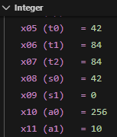

Pre-Swapping:
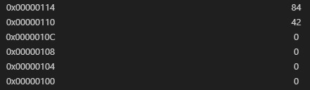

Post-swapping:
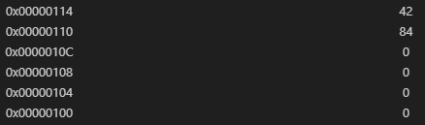

Task 4 Provide appropriately commented codes

Add screenshots of your results

Assessment Rubrics

Lab 03: Implementing Jump & Return Instructions in RISC – V Assembly Language

Task No. | LR 2  Code | LR 5  Results
Task 1 | /10 | /05
Task 2 | /10 | /10
Task 3 | /10 | /10
Task 4 | /15 | /10
Total Points: 100 | /45 | /35
CLO Mapped | CLO 2

Affective Domain | Rubric | Points | CLO Mapped
AR7 | Report Submission & Git Upload | /10 & /10 | CLO2

CLO | Total Points | Points Obtained
2 | 100
Total | 100

For description of different levels of the mapped rubrics, please refer to the Lab Evaluation Assessment Rubrics and Affective Domain Assessment Rubrics provided here.

Lab Evaluation Assessment Rubric
# | Assessment Elements | Level 1: Unsatisfactory | Level 2: Developing | Level 3: Good | Level 4: Exemplary
LR2 | Program/Co de/ Simulation Model/ Network Model | Program/code/simulation model/network model does not implement the required functionality and has several errors. The student is not able to utilize even the basic tools of the software. | Program/code/simulation model/network model has some errors and does not produce completely accurate results. Student has limited command on the basic tools of the software. | Program/code/simulation model/network model gives correct output but not efficiently implemented or implemented by computationally complex routine. | Program/code/simulation  /network model is efficiently implemented and gives correct output. Student has full command on the basic tools of the software.
LR5 | Results & Plots | Figures/ graphs / tables are not developed or are poorly constructed with erroneous results. Titles, captions, units are not mentioned.  Data is presented in an obscure manner. | Figures, graphs and tables are drawn but contain errors. Titles, captions, units are not accurate. Data presentation is not too clear. | All figures, graphs, tables are correctly drawn but contain minor errors or some of the details are missing. | Figures / graphs / tables are correctly drawn and appropriate titles/captions and proper units are mentioned. Data presentation is systematic.
AR9 | Report Content/Code Comments | No summary provided. The number/amount of tasks completed below the level of satisfaction and/or submitted late | Couldn’t provide good summary of in-lab tasks. Some major tasks were completed but not explained well.  Submission on time. Some major plots and figures provided | Good summary of In-lab tasks. All major tasks completed except few minor ones. The work is supported by some decent explanations, Submission on time, All necessary plots, and figures provided | Outstanding Summary of In-Lab tasks. All task completed and explained well, submitted on time, good presentation of plots and figure with proper label, titles and captions

